**Tugas Pertemuan Ke – 8**

**Bab 8 : SQL Lite Database**

|  |  |
| --- | --- |
| **Nama** | Alfina |
| **Nim** | 2018041 |
| **Kelas** | B |
| **Pemberi Tugas** | Marie Pangestu (2118101) |

1. **Melanjutkan projek sesuai tema dengan mengimplementasikan SQLite dan tambahkan menu pada action bar atau navigation bar. Pastikan tampilan IU yang dibuat sebagus dan sekreatif mungkin.**
2. **Langkah – langkah pengerjaan**
3. Membuat *project* baru pada Android Studio dengan memilih *New Projec*t seperti pada gambar dibawah

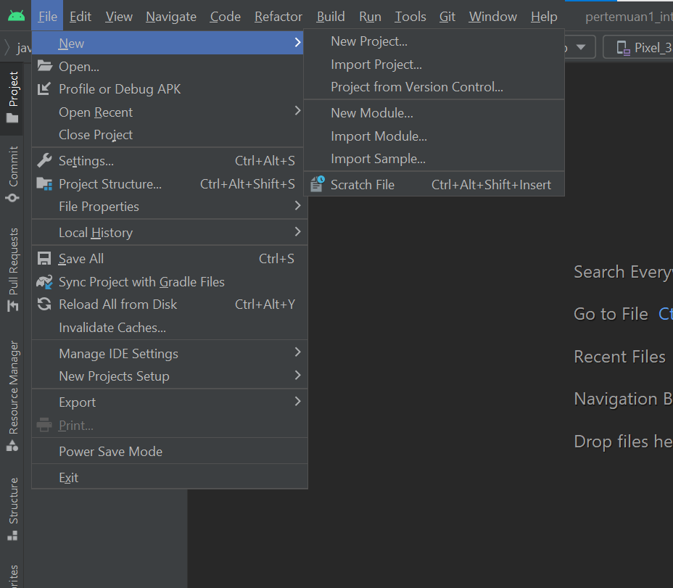

#### Halaman Awal Android Studio

1. Praktikan memilih “*Empy Activity*” pada “*Phone and Tablet*” seperti pada gambar dibawah

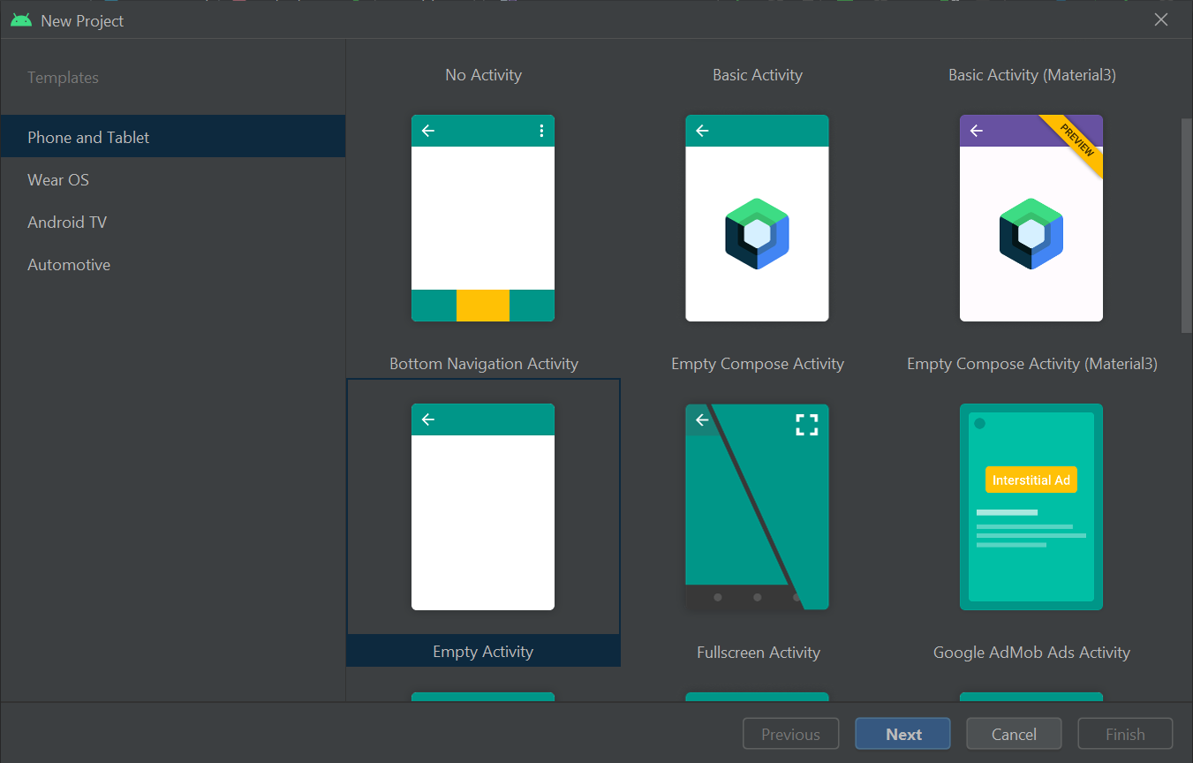

#### *Empty Activity* pada *Phone and Tablet*

1. Mengisi identitas project seperti pada gambar. Disarankan memakai minimum SDK 27 ( Android 8.1 Oreo ). Jika sudah klik *finish*

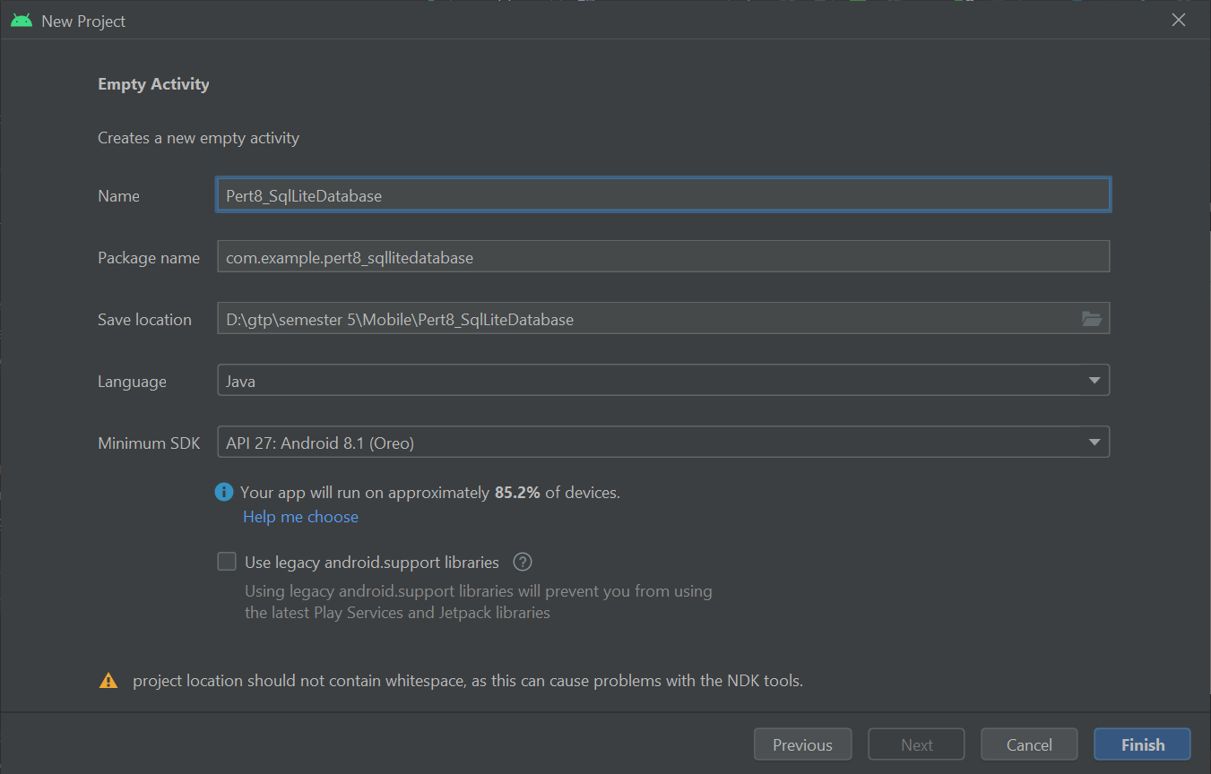

#### Mengisi Identitas *Project*

1. Langkah pertama double klik pada setting.gradle

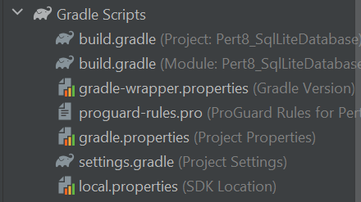

#### Setting Gradle

1. Kemudian tambahkan jcenter(), lalu comment //mavenCentral() seperti pada source code di bawah ini

Source code

|  |
| --- |
| pluginManagement {  repositories {  gradlePluginPortal()  google()  jcenter()  //mavenCentral()  }  }  dependencyResolutionManagement {  repositoriesMode.set(RepositoriesMode.FAIL_ON_PROJECT_REPOS)  repositories {  google()  jcenter()  //mavenCentral()  }  }  rootProject.name = "Pert8_SqlLiteDatabase"  include ':app' |

1. Kemudian double klik pada build.gradle



#### Build Gradle

1. Kemudian tambahkan library seperti gambar dibawah ini lalu klik “Sync Now” pada pop up gradle yang akan muncul.

Source code

|  |
| --- |
| //activation binding view  buildFeatures{  viewBinding true  }  //crop image  api 'com.theartofdev.edmodo:android-image-cropper:2.8.0'  //loading image in image view  implementation 'com.squareup.picasso:picasso:2.5.2' |

*Source code* di atas adalah *source code* pada *Gradle Script* yang digunakan untuk menambahkan *library* sesuai kebutuhan.

1. Kemudian double file AndroidManifest.xml, lalu tambahkan kode seperti gambar dibwah ini.

Source code

|  |
| --- |
| <?xml version="1.0" encoding="utf-8"?>  <manifest xmlns:android="http://schemas.android.com/apk/res/android"  xmlns:tools="http://schemas.android.com/tools"  package="com.example.pert8_sqllitedatabase">  <uses-permission android:name="android.permission.CAMERA" />  <uses-permission android:name="android.permission.READ_EXTERNAL_STORAGE" />  <uses-permission android:name="android.permission.WRITE_EXTERNAL_STORAGE" />  <application  android:allowBackup="true"  android:dataExtractionRules="@xml/data_extraction_rules"  android:fullBackupContent="@xml/backup_rules"  android:icon="@mipmap/ic_launcher"  android:label="@string/app_name"  android:roundIcon="@mipmap/ic_launcher_round"  android:supportsRtl="true"  android:theme="@style/Theme.Pert8_SqlLiteDatabase"  tools:targetApi="31">  <activity  android:name=".DisplayData"  android:exported="false" />  <activity  android:name=".MainActivity5"  android:exported="false" />  <activity  android:name=".MainActivity4"  android:exported="false" />  <activity  android:name=".MainActivity3"  android:exported="false" />  <activity  android:name=".MainActivity2"  android:exported="false" />  <activity  android:name=".MainActivity"  android:exported="true">  <intent-filter>  <action android:name="android.intent.action.MAIN" />  <category android:name="android.intent.category.LAUNCHER" />  </intent-filter>  </activity>  <receiver android:name=".AlarmReceiver" />  <activity android:name="com.theartofdev.edmodo.cropper.CropImageActivity" />  </application>  </manifest> |

1. Buatlah vector assets pada drawable dengan cara klik kanan pada folder drawable lalu pilih New >> Vector Assets

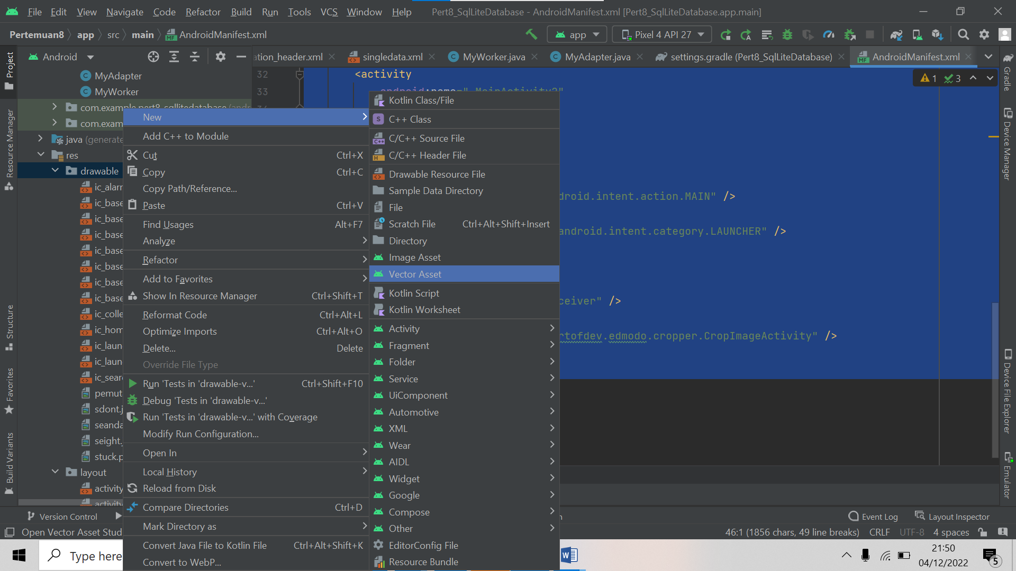

#### Membuat Vector Assets

1. Carilah clip art more vert dan star rate sesuai seperti pada gambar dibwah ini lalu simpan.

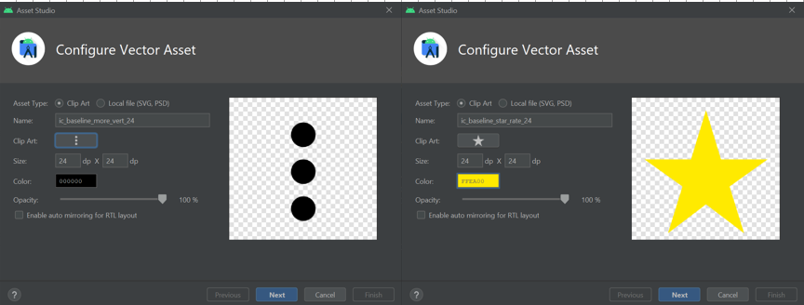

#### More Vert dan Star Rate

1. Kemudian membuat empty activity dengan cara klik kanan pada com.example > new > Activity > Empty Activity.

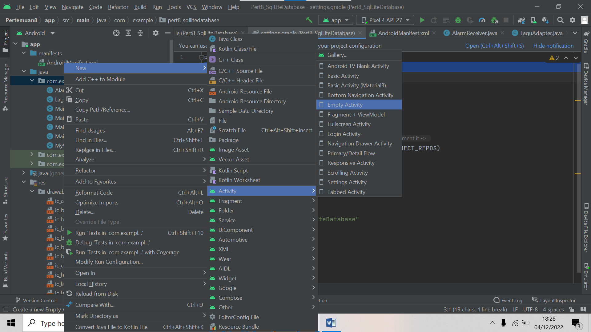

#### Membuat Activity Baru

1. Berikan identitas Empty Activity seperti pada gambar dibawah ini.

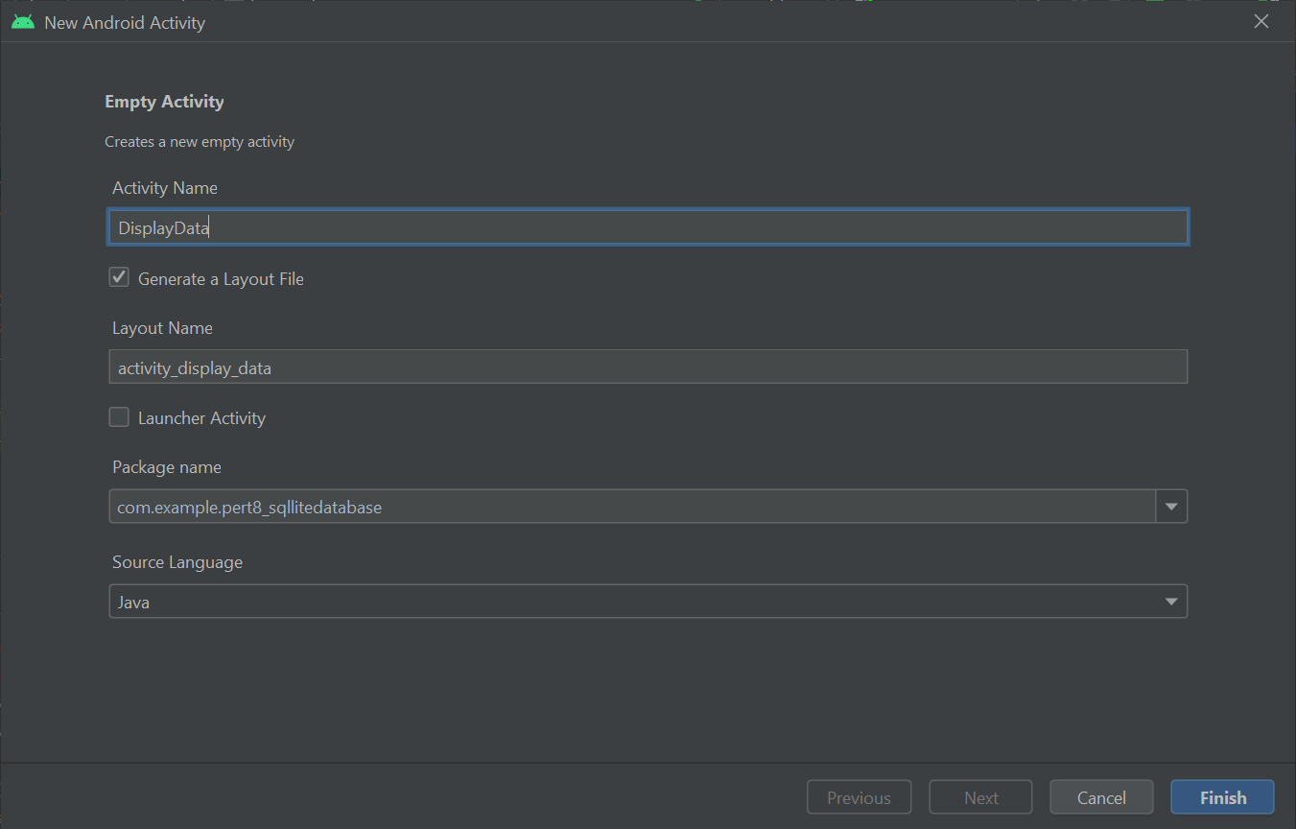

#### Memberi Identitak pada Activity

1. Kemudian membuat java class baru dengan cara klik kanan pada com.example > new > Java Class.

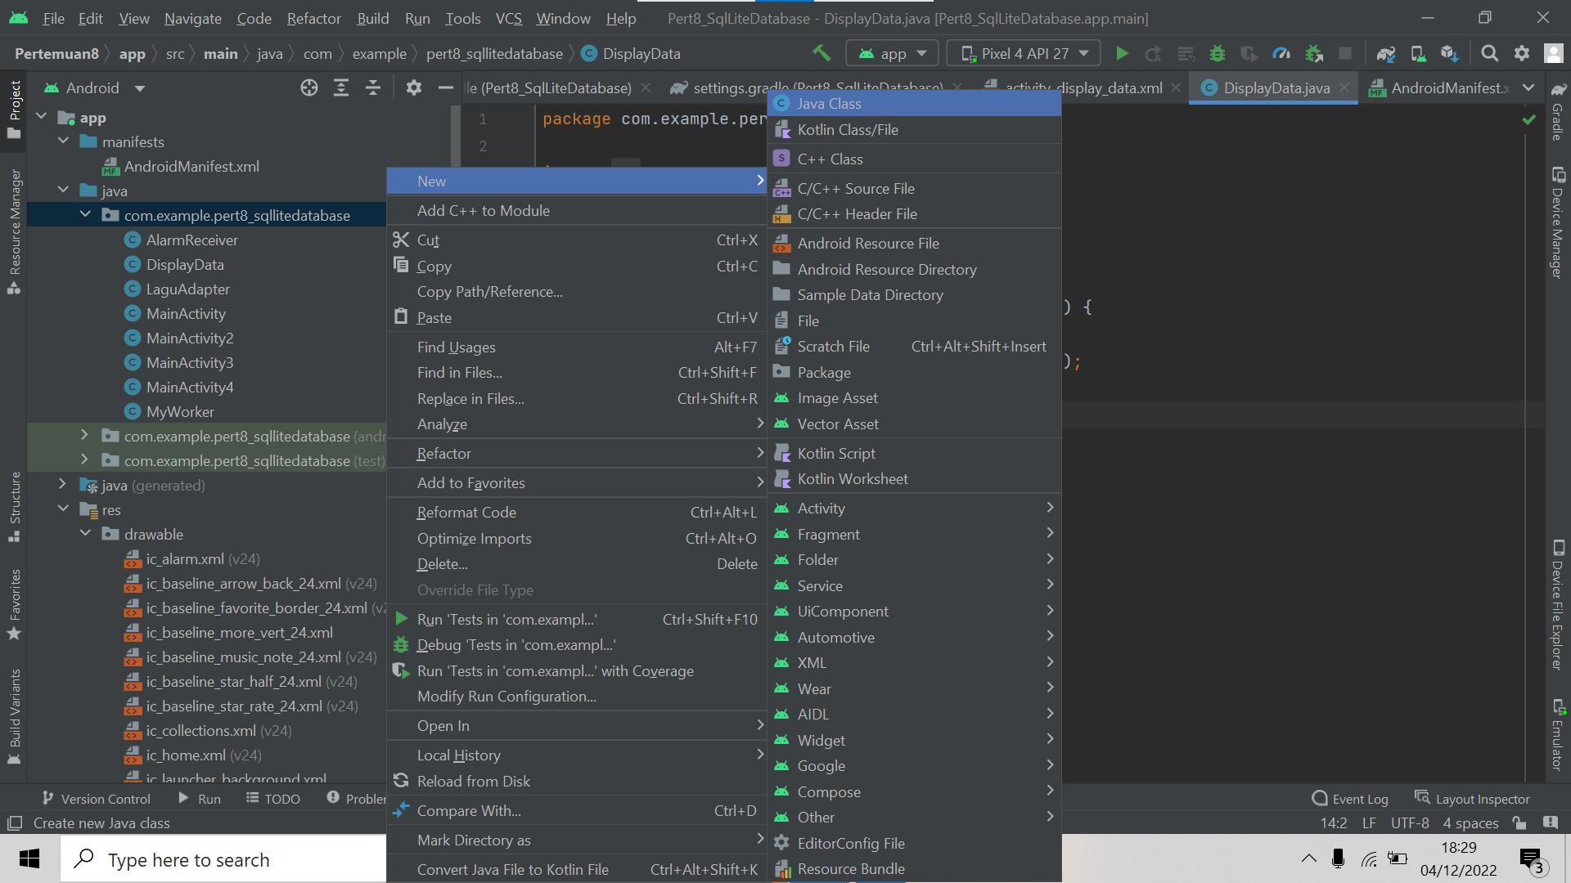

#### Membuat Class Java Baru

1. Buat 3 file Java class dengan nama masing – masing adalah DBmain, Model, MyAdapeter seperti pada gambar dibawah ini.

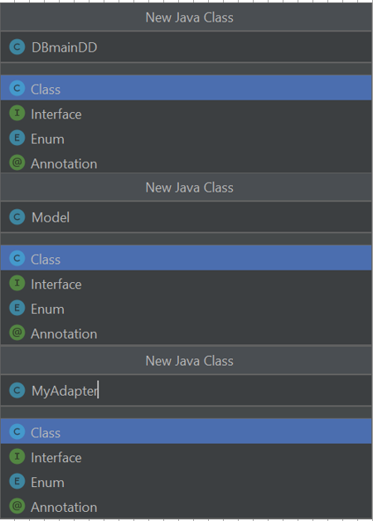

#### Identitas Java Class Baru

1. Kemudian membuat Layout Resource File dengan cara klik kanan pada folder layout > new > Layout Resource File.

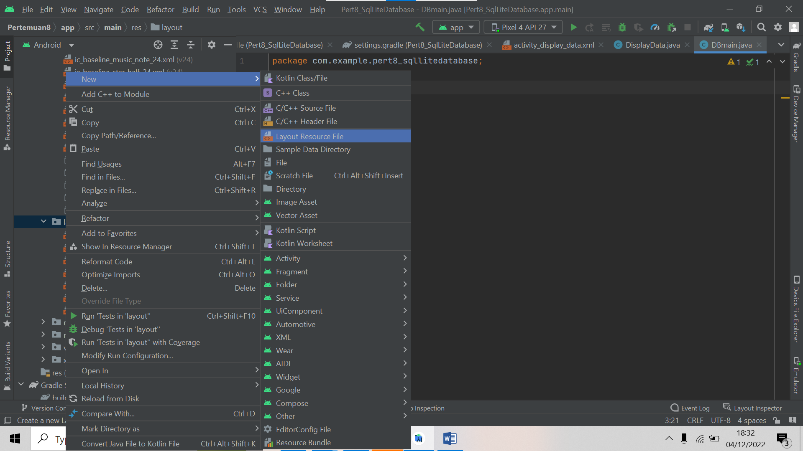

#### Membuat Layout Resource File

1. Beri identitas Layout Resource File seperti pada gambar dibawah ini.

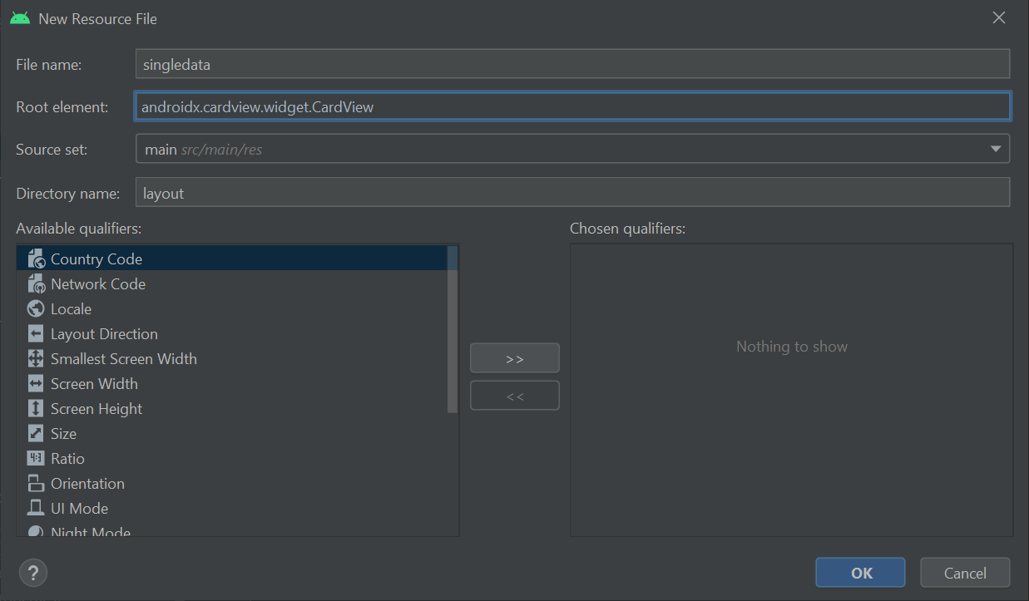

#### Identitas Layout Resource File

1. Kemudian buka folder layout > double klik file singledata.xml, lalu tambahkan source code berikut.

Source code

|  |
| --- |
| <?xml version="1.0" encoding="utf-8"?>  <androidx.cardview.widget.CardView  xmlns:android="http://schemas.android.com/apk/res/android"  android:layout_width="wrap_content"  android:layout_height="130dp"  xmlns:app="http://schemas.android.com/apk/res-auto"  app:cardElevation="2dp"  app:cardPreventCornerOverlap="true"  app:cardUseCompatPadding="true"  app:cardCornerRadius="8dp">  <RelativeLayout  android:layout_width="match_parent"  android:layout_height="match_parent">  <ImageButton  android:background="@null"  android:layout_width="wrap_content"  android:layout_height="wrap_content"  android:layout_marginTop="10dp"  android:id="@+id/flowmenu"  android:layout_centerVertical="true"  android:layout_alignParentRight="true"  android:src="@drawable/ic_baseline_more_vert_24"  android:layout_alignParentTop="true"/>  <ImageView  android:scaleType="fitXY"  android:layout_marginTop="10dp"  android:layout_marginBottom="10dp"  android:layout_width="100dp"  android:layout_height="100dp"  android:paddingLeft="10dp"  android:id="@+id/viewavatar"  android:src="@drawable/ic_launcher_background"/>  <TextView  android:layout_width="match_parent"  android:layout_height="wrap_content"  android:layout_toRightOf="@+id/viewavatar"  android:text="@string/app_name"  android:id="@+id/txt_judullagu"  android:layout_marginTop="10dp"  android:layout_marginLeft="20dp"/>  <LinearLayout  android:layout_width="match_parent"  android:layout_height="20dp"  android:layout_toRightOf="@+id/viewavatar"  android:layout_alignTop="@+id/txt_judullagu"  android:layout_marginTop="25dp"  android:layout_marginStart="10dp"  android:id="@+id/linear"  android:orientation="horizontal">  <ImageView  android:layout_width="30dp"  android:layout_height="wrap_content"  android:foregroundGravity="left"  app:srcCompat="@drawable/ic_baseline_star_rate_24" />  <TextView  android:layout_width="match_parent"  android:layout_height="match_parent"  android:layout_toRightOf="@+id/viewavatar"  android:text="@string/app_name"  android:id="@+id/txt_artis"/>  </LinearLayout>  <TextView  android:layout_width="match_parent"  android:layout_height="wrap_content"  android:layout_toRightOf="@+id/viewavatar"  android:text="@string/app_name"  android:layout_alignTop="@+id/linear"  android:id="@+id/txt_tahun"  android:layout_marginTop="30dp"  android:layout_marginLeft="20dp"/>  </RelativeLayout>  </androidx.cardview.widget.CardView> |

### Tabel Komponen singledata_xml

|  |  |  |  |
| --- | --- | --- | --- |
| **No** | **Object** | **Property** | **Value** |
|  | ImageButton | Id  Image | @+id/flowmenu  @drawable/ic_baseline_more_vert_24 |
|  | ImageView | Id  Image | @+id/viewavatar  @drawable/ic_launcher_background |
|  | TextView | Id  Text | @+id/txt_judullagu  @string/app_name |
|  | ImageView2 | srcCompat | @drawable/ic_baseline_star_rate_24 |
|  | TextView2 | Id  Text | @+id/txt_artis  @string/app_name |
|  | TextView3 | Id  Text | @+id/txt_tahun  @string/app_name |

1. Kemudian buka folder com.example > double klik file DBmain.java, lalu tambahkan source code berikut.

Source code

|  |
| --- |
| package com.example.pert8_sqllitedatabase;  import android.content.Context;  import android.database.sqlite.SQLiteDatabase;  import android.database.sqlite.SQLiteOpenHelper;  import androidx.annotation.Nullable;  public class DBmain extends SQLiteOpenHelper {  public static final String DBNAME="lagu.db";  public static final String TABLENAME="daftar_lagu";  public static final int VER=1;  public DBmain(@Nullable Context context) {  super(context, DBNAME, null, VER);  }  @Override  public void onCreate(SQLiteDatabase db) {  String query = "create table "+TABLENAME+"(id integer primary key, judul_lagu TEXT, artis TEXT, tahun TEXT, avatar blob)";  db.execSQL(query);  }  @Override  public void onUpgrade(SQLiteDatabase db, int oldVersion, int newVersion) {  String query = "drop table if exists "+TABLENAME+"";  db.execSQL(query);  onCreate(db);  }  } |

Analisa :

*Source code* di atas adalah *source code* pada class DBmain yang betipe file java. *Source* *code* di atas terdapat import yang berguna sebagai membuat database. Pada *source* *code* tersebut digunakan untuk membuat nama tabel pada database. Dan terdapat fungsi *Void onCreat/.*

1. Kemudian buka folder com.example > double klik file Model.java, lalu tambahkan source code berikut.

Source code

|  |
| --- |
| package com.example.pert8_sqllitedatabase;  public class Model {  private int id;  private byte[]proavatar;  private String userjudul_lagu;  private String userartis;  private String usertahun;  //constructor  public Model(int id, byte[] proavatar, String userjudul_lagu, String userartis, String usertahun) {  this.id = id;  this.proavatar = proavatar;  this.userjudul_lagu = userjudul_lagu;  this.userartis = userartis;  this.usertahun = usertahun;  }  //getter and setter method  public int getId() {  return id;  }  public void setId(int id) {  this.id = id;  }  public byte[] getProavatar() {  return proavatar;  }  public void setProavatar(byte[] proavatar) {  this.proavatar = proavatar;  }  public String getUserjudul_lagu() {  return userjudul_lagu;  }  public void setUserjudul_lagu(String userjudul_lagu) {  this.userjudul_lagu = userjudul_lagu;  }  public String getUserartis() {  return userartis;  }  public void setUserartis(String userartis) {  this.userartis = userartis;  }  public String getUsertahun() {  return usertahun;  }  public void setUsertahun(String usertahun) {  this.usertahun = usertahun;  }  } |

Analisa :

*Source code* di atas adalah *source code* pada class DBmain yang betipe file java. Source code diaatas berguna untuk membuat model pada android. Dan juga terdapat pemanggilan id dan set id.

1. Kemudian klik kanan pada folder menu > New > Menu Resource File

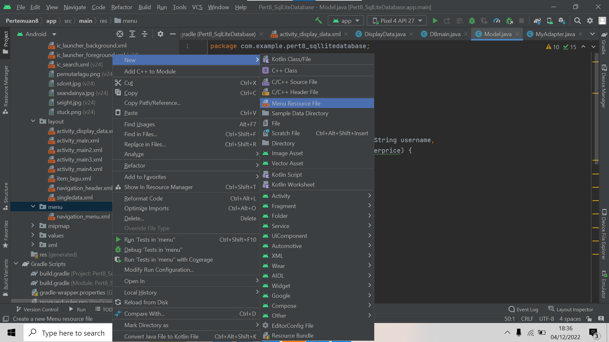

#### Membuat Menu Resource File

1. Kemudian berikan identitas Menu Resource File seperti pada gambar dibawah ini

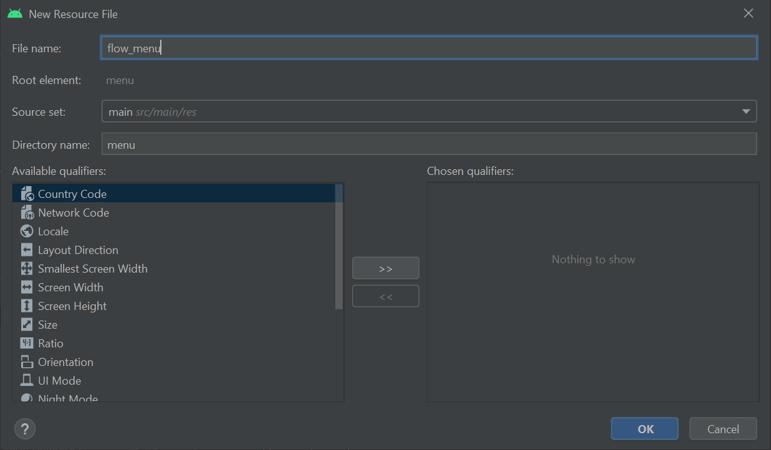

#### Identitas Menu Resource File

1. Langkah selanjutnya buka file flow_menu.xml pada folder menu, kemudian tambahkan source code berikut.

Source code

|  |
| --- |
| <?xml version="1.0" encoding="utf-8"?>  <menu xmlns:android="http://schemas.android.com/apk/res/android">  <item android:title="Edit"  android:id="@+id/edit_menu"/>  <item android:title="Delete"  android:id="@+id/delete_menu"/>  </menu> |

### Tabel Komponen flow_menu.xml

|  |  |  |  |
| --- | --- | --- | --- |
| **No** | **Object** | **Property** | **Value** |
|  | edit_menu | Id  Title | edit_menu  Edit |
|  | delete_menu | Id  Title | delete_menu  Delete |

1. Kemudian tambahkan source code berikut pada activity_main5.xml.

Source code

|  |
| --- |
| <?xml version="1.0" encoding="utf-8"?>  <LinearLayout  xmlns:android="http://schemas.android.com/apk/res/android"  xmlns:app="http://schemas.android.com/apk/res-auto"  xmlns:tools="http://schemas.android.com/tools"  android:layout_width="match_parent"  android:layout_height="match_parent"  android:orientation="vertical"  tools:context=".MainActivity5">  <ImageView  android:layout_marginTop="14dp"  android:layout_gravity="center"  android:layout_width="150dp"  android:layout_height="150dp"  android:src="@drawable/ic_baseline_library_music_24"  android:id="@+id/edtimage"/>  <EditText  android:layout_width="match_parent"  android:layout_height="wrap_content"  android:hint="Judul Lagu"  android:inputType="text"  android:id="@+id/edtjudullagu"  android:layout_marginTop="10dp"/>  <EditText  android:layout_width="match_parent"  android:layout_height="wrap_content"  android:hint="Artis"  android:inputType="text"  android:id="@+id/edtartis"  android:layout_marginTop="10dp"/>  <EditText  android:layout_width="match_parent"  android:layout_height="wrap_content"  android:hint="Tahun"  android:inputType="text"  android:id="@+id/edttahun"  android:layout_marginTop="10dp"/>  <LinearLayout  android:layout_width="match_parent"  android:layout_height="wrap_content"  android:orientation="horizontal"  android:layout_margin="10dp">  <Button  android:layout_width="wrap_content"  android:layout_height="wrap_content"  android:layout_weight="1"  android:id="@+id/btn_submit"  android:text="Submit"/>  <Button  android:layout_width="wrap_content"  android:layout_height="wrap_content"  android:id="@+id/btn_edit"  android:visibility="gone"  android:text="Edit"  android:layout_weight="1"/>  <Button  android:layout_width="wrap_content"  android:layout_height="wrap_content"  android:text="Display"  android:id="@+id/btn_display"  android:layout_weight="1"/>  </LinearLayout>  </LinearLayout> |

### Tabel Komponen activity_main5.xml

|  |  |  |  |
| --- | --- | --- | --- |
| **No** | **Object** | **Property** | **Value** |
|  | ImageView | Id  Image | @+id/edtimage  @drawable/gallery |
|  | EditText | Id  InputType | @+id/edtjudullagu  Text |
|  | EditText2 | Id  InputType | @+id/edtartis  Text |
|  | EditText3 | Id  InputType | @+id/edttahun  Text |
|  | Button1 | Id  Text | @+id/btn_submit  Submit |
|  | Button2 | Id  Text | @+id/btn_edit  Edit |
|  | Button3 | Id  Text | @+id/btn_display  Display |

1. Kemudian tambahkan source code berikut pada activity_display_data.xml.

Source code

|  |
| --- |
| <?xml version="1.0" encoding="utf-8"?>  <RelativeLayout  xmlns:android="http://schemas.android.com/apk/res/android"  xmlns:app="http://schemas.android.com/apk/res-auto"  xmlns:tools="http://schemas.android.com/tools"  android:layout_width="match_parent"  android:layout_height="match_parent"  tools:context=".DisplayData">  <Button  android:layout_marginTop="10dp"  android:layout_marginLeft="10dp"  android:layout_marginBottom="10dp"  android:layout_width="wrap_content"  android:layout_height="wrap_content"  android:id="@+id/btn_create"  android:text="Create" />  <androidx.recyclerview.widget.RecyclerView  android:layout_marginTop="75dp"  android:layout_width="match_parent"  android:layout_height="1000dp"  android:id="@+id/rv"/>  </RelativeLayout> |

### Tabel Komponen activity_display_data.xml

|  |  |  |  |
| --- | --- | --- | --- |
| **No** | **Object** | **Property** | **Value** |
|  | Button | Id  Text | @+id/btn_create  Create |

1. Kemudian tambahkan source code berikut pada MyAdapter.java

Source code

|  |
| --- |
| package com.example.pert8_sqllitedatabase;  import static com.example.pert8_sqllitedatabase.DBmain.TABLENAME;  import android.annotation.SuppressLint;  import android.content.Context;  import android.content.Intent;  import android.database.sqlite.SQLiteDatabase;  import android.graphics.Bitmap;  import android.graphics.BitmapFactory;  import android.os.Bundle;  import android.view.LayoutInflater;  import android.view.MenuItem;  import android.view.View;  import android.view.ViewGroup;  import android.widget.ImageButton;  import android.widget.ImageView;  import android.widget.PopupMenu;  import android.widget.TextView;  import android.widget.Toast;  import androidx.annotation.NonNull;  import androidx.recyclerview.widget.RecyclerView;  import java.util.ArrayList;  public class MyAdapter extends RecyclerView.Adapter<MyAdapter.ViewHolder> {  Context context;  int singledata;  ArrayList<Model> modelArrayList;  SQLiteDatabase sqLiteDatabase;  //generate constructor  public MyAdapter(Context context, int singledata, ArrayList<Model> modelArrayList, SQLiteDatabase sqLiteDatabase) {  this.context = context;  this.singledata = singledata;  this.modelArrayList = modelArrayList;  this.sqLiteDatabase = sqLiteDatabase;  }  @NonNull  @Override  public MyAdapter.ViewHolder onCreateViewHolder(@NonNull ViewGroup parent, int viewType) {  LayoutInflater inflater = LayoutInflater.from(context);  View view = inflater.inflate(R.layout.singledata, null);  return new ViewHolder(view);  }  @Override  public void onBindViewHolder(@NonNull MyAdapter.ViewHolder holder, @SuppressLint("RecyclerView") int position) {  final Model model = modelArrayList.get(position);  byte[] image = model.getProavatar();  Bitmap bitmap = BitmapFactory.decodeByteArray(image, 0, image.length);  holder.imageavatar.setImageBitmap(bitmap);  holder.txtjudul_lagu.setText(model.getUserjudul_lagu());  holder.txtartis.setText(model.getUserartis());  holder.txttahun.setText(model.getUsertahun());  //flow menu  holder.flowmenu.setOnClickListener(new View.OnClickListener() {  @Override  public void onClick(View v) {  PopupMenu popupMenu = new PopupMenu(context, holder.flowmenu);  popupMenu.inflate(R.menu.flow_menu);  popupMenu.setOnMenuItemClickListener(new PopupMenu.OnMenuItemClickListener() {  @Override  public boolean onMenuItemClick(MenuItem item) {  switch (item.getItemId()) {  case R.id.edit_menu:  //edit operation  Bundle bundle = new Bundle();  bundle.putInt("id", model.getId());  bundle.putString("judul_lagu", model.getUserjudul_lagu());  bundle.putString("artis", model.getUserartis());  bundle.putString("tahun", model.getUsertahun());  bundle.putByteArray("avatar", model.getProavatar());  Intent intent = new Intent(context, MainActivity5.class);  intent.putExtra("userdata", bundle);  context.startActivity(intent);  break;  case R.id.delete_menu:  //delete operation  DBmain dBmain = new DBmain(context);  sqLiteDatabase = dBmain.getReadableDatabase();  long recdelete = sqLiteDatabase.delete(TABLENAME, "id=" + model.getId(), null);  if (recdelete != -1) {  Toast.makeText(context, "DataDeleted",Toast.LENGTH_SHORT).show();  //remove positon after deleted  modelArrayList.remove(position);  //update data  notifyDataSetChanged();  }  break;  default:  return false;  }  return false;  }  });  //display menu  popupMenu.show();  }  });  }  @Override  public int getItemCount() {  return modelArrayList.size();  }  public class ViewHolder extends RecyclerView.ViewHolder {  ImageView imageavatar;  TextView txtjudul_lagu, txtartis, txttahun;  ImageButton flowmenu;  public ViewHolder(@NonNull View itemView) {  super(itemView);  imageavatar = (ImageView) itemView.findViewById(R.id.viewavatar);  txtjudul_lagu = (TextView) itemView.findViewById(R.id.txt_judullagu);  txtartis = (TextView) itemView.findViewById(R.id.txt_artis);  txttahun = (TextView) itemView.findViewById(R.id.txt_tahun);  flowmenu = (ImageButton) itemView.findViewById(R.id.flowmenu);  }  }  } |

Analisa :

*Source code* di atas adalah *source code* pada class MyAdapter yang betipe file java. *Source* *code* diaatas terdapat *variable* *singledata* dengan tipe data *integer*, lalu terdapat fungsi Myadapter. Lalu terdapat fungsi *gerItemCount* yang bersifat *public*, fungsi ini mengembalikan *modeArrayList*.

1. Kemudian tambahkan source code berikut pada MainActivity5.java

Source code

|  |
| --- |
| package com.example.pert8_sqllitedatabase;  import static com.example.pert8_sqllitedatabase.DBmain.TABLENAME;  import androidx.annotation.NonNull;  import androidx.annotation.Nullable;  import androidx.appcompat.app.AppCompatActivity;  import androidx.core.content.ContextCompat;  import android.Manifest;  import android.content.ContentValues;  import android.content.Intent;  import android.content.pm.PackageManager;  import android.database.sqlite.SQLiteDatabase;  import android.graphics.Bitmap;  import android.graphics.BitmapFactory;  import android.graphics.drawable.BitmapDrawable;  import android.net.Uri;  import android.os.Bundle;  import android.view.View;  import android.widget.ImageView;  import android.widget.Toast;  import com.example.pert8_sqllitedatabase.databinding.ActivityMain5Binding;  import com.squareup.picasso.Picasso;  import com.theartofdev.edmodo.cropper.CropImage;  import java.io.ByteArrayOutputStream;  public class MainActivity5 extends AppCompatActivity {  private ActivityMain5Binding binding;  DBmain dBmain;  SQLiteDatabase sqLiteDatabase;  int id = 0;  public static final int MY_CAMERA_REQUEST_CODE = 100;  public static final int MY_STORAGE_REQUEST_CODE = 101;  String cameraPermission[];  String storagePermission[];  @Override  protected void onCreate(Bundle savedInstanceState) {  super.onCreate(savedInstanceState);  binding =ActivityMain5Binding.inflate(getLayoutInflater());  setContentView(binding.getRoot());  dBmain = new DBmain(this);  //findid();  insertData();  editData();  binding.edtimage.setOnClickListener(new View.OnClickListener() {  @Override  public void onClick(View v) {  int avatar = 0;  if (avatar == 0) {  if (!checkCameraPermission()) {  requestCameraPermission();  } else {  pickFromGallery();  }  } else if (avatar == 1) {  if (!checkStoragePermission()) {  requestStoragePermission();  } else {  pickFromGallery();  }  }  }  });  }  private void editData() {  if (getIntent().getBundleExtra("userdata")!= null){Bundle bundle = getIntent().getBundleExtra("userdata");  id = bundle.getInt("id");  //for set name  binding.edtjudullagu.setText(bundle.getString("judul_lagu"));  binding.edtartis.setText(bundle.getString("artis"));  binding.edttahun.setText(bundle.getString("tahun"));  //for image  byte[]bytes = bundle.getByteArray("avatar");  Bitmap bitmap = BitmapFactory.decodeByteArray(bytes, 0, bytes.length);  binding.edtimage.setImageBitmap(bitmap);  //visible edit button and hide submit button  binding.btnSubmit.setVisibility(View.GONE);  binding.btnEdit.setVisibility(View.VISIBLE);  }  }  private void requestStoragePermission() {  requestPermissions(storagePermission, MY_STORAGE_REQUEST_CODE);  }  private boolean checkStoragePermission() {  boolean result = ContextCompat.checkSelfPermission(this, Manifest.permission.WRITE_EXTERNAL_STORAGE) == (PackageManager.PERMISSION_GRANTED);  return result;  }  private void pickFromGallery() {  CropImage.activity().start(this);  }  private void requestCameraPermission() {  requestPermissions(cameraPermission, MY_CAMERA_REQUEST_CODE);  }  private boolean checkCameraPermission() {  boolean result = ContextCompat.checkSelfPermission(this, Manifest.permission.WRITE_EXTERNAL_STORAGE) == (PackageManager.PERMISSION_GRANTED);  boolean result1 = ContextCompat.checkSelfPermission(this, Manifest.permission.CAMERA) == (PackageManager.PERMISSION_GRANTED);  return result && result1;  }  private void insertData() {  binding.btnSubmit.setOnClickListener(new View.OnClickListener() {  @Override  public void onClick(View v) {  ContentValues cv = new ContentValues();  cv.put("judul_lagu", binding.edtjudullagu.getText().toString());  cv.put("artis", binding.edtartis.getText().toString());  cv.put("avatar", imageViewToBy(binding.edtimage));  cv.put("tahun", binding.edttahun.getText().toString());  sqLiteDatabase = dBmain.getWritableDatabase();  Long rec = sqLiteDatabase.insert("daftar_lagu", null, cv);  if (rec != null) {  Toast.makeText(MainActivity5.this, "Data Inserted", Toast.LENGTH_SHORT).show();  binding.edtjudullagu.setText("");  binding.edtimage.setImageResource(R.drawable.ic_baseline_library_music_24);  binding.edtartis.setText("");  binding.edttahun.setText("");  } else {  Toast.makeText(MainActivity5.this, "Something Wrong", Toast.LENGTH_SHORT).show();  }  }  });  //for view display  binding.btnDisplay.setOnClickListener(new View.OnClickListener() {  @Override  public void onClick(View v) {  startActivity(new Intent(MainActivity5.this, DisplayData.class));  }  });  //for storing new data or update data  binding.btnEdit.setOnClickListener(new View.OnClickListener() {  @Override  public void onClick(View v) {  ContentValues cv = new ContentValues();  cv.put("judul_lagu", binding.edtjudullagu.getText().toString());  cv.put("artis", binding.edtartis.getText().toString());  cv.put("tahun", binding.edttahun.getText().toString());  cv.put("avatar", imageViewToBy(binding.edtimage));  sqLiteDatabase = dBmain.getWritableDatabase();  long recedit = sqLiteDatabase.update(TABLENAME, cv, "id=" + id, null);  if (recedit != -1) {  Toast.makeText(MainActivity5.this, "Update Succesfully", Toast.LENGTH_SHORT).show();  //clear data adfte submit  binding.edtjudullagu.setText("");  binding.edtartis.setText("");  binding.edttahun.setText("");  binding.edtimage.setImageResource(R.drawable.ic_baseline_library_music_24);  //edit hide and submit visible  binding.btnEdit.setVisibility(View.GONE);  binding.btnSubmit.setVisibility(View.VISIBLE);  Intent a = new Intent(MainActivity5.this, DisplayData.class);  startActivity(a);  }  }  });  }  public static byte[] imageViewToBy(ImageView avatar) {  Bitmap bitmap = ((BitmapDrawable) avatar.getDrawable()).getBitmap();  ByteArrayOutputStream stream = new ByteArrayOutputStream();  bitmap.compress(Bitmap.CompressFormat.JPEG, 50, stream);  byte[] bytes = stream.toByteArray();  return bytes;  }  @Override  public void onRequestPermissionsResult(int requestCode, @NonNull String[] permissions, @NonNull int[] grantResults) {  super.onRequestPermissionsResult(requestCode, permissions, grantResults);  switch (requestCode) {  case MY_CAMERA_REQUEST_CODE: {  if (grantResults.length > 0) {  boolean camera_accepted = grantResults[0] == PackageManager.PERMISSION_GRANTED;  boolean storage_accepted = grantResults[1] == PackageManager.PERMISSION_GRANTED;  if (camera_accepted && storage_accepted) {  pickFromGallery();  } else {  Toast.makeText(this, "enable camera and storage permission", Toast.LENGTH_SHORT).show();  }  }  }break;  case MY_STORAGE_REQUEST_CODE: {  boolean storage_accepted = grantResults[0] == PackageManager.PERMISSION_GRANTED;  if (storage_accepted) {  pickFromGallery();  } else {  Toast.makeText(this, "please enable storage permission", Toast.LENGTH_SHORT).show();  }  }  break;  }  }  @Override  protected void onActivityResult(int requestCode, int  resultCode, @Nullable Intent data) {  super.onActivityResult(requestCode, resultCode, data);  if(requestCode ==CropImage.CROP_IMAGE_ACTIVITY_REQUEST_CODE){  CropImage.ActivityResult result = CropImage.getActivityResult(data);  if(resultCode == RESULT_OK){  Uri resultUri = result.getUri();  Picasso.with(this).load(resultUri).into(binding.edtimage);  }  }  }} |

Analisa :

*Source code* di atas adalah *source code* pada class MainActivity5 yang betipe file java. *Source code* diaatas berguna untuk memberikan fungsi *input* data. Terdapat juga fungsi yang digunakan pada button pada *activity5.*

1. Kemudian tambahkan source code berikut pada DisplayData.java

Source code

|  |
| --- |
| package com.example.pert8_sqllitedatabase;  import static com.example.pert8_sqllitedatabase.DBmain.TABLENAME;  import androidx.appcompat.app.AppCompatActivity;  import androidx.recyclerview.widget.LinearLayoutManager;  import androidx.recyclerview.widget.RecyclerView;  import android.content.Intent;  import android.database.Cursor;  import android.database.sqlite.SQLiteDatabase;  import android.os.Bundle;  import android.view.View;  import com.example.pert8_sqllitedatabase.databinding.ActivityDisplayDataBinding;  import java.util.ArrayList;  public class DisplayData extends AppCompatActivity {  DBmain dBmain;  SQLiteDatabase sqLiteDatabase;  RecyclerView recyclerView;  MyAdapter myAdapter;  private ActivityDisplayDataBinding binding;  @Override  protected void onCreate(Bundle savedInstanceState) {  super.onCreate(savedInstanceState);  binding = ActivityDisplayDataBinding.inflate(getLayoutInflater());  setContentView(binding.getRoot());  findId();  dBmain = new DBmain(this);  displayData();  recyclerView.setLayoutManager(new LinearLayoutManager(this, RecyclerView.VERTICAL, false));  binding.btnCreate.setOnClickListener(new View.OnClickListener() {  @Override  public void onClick(View v) {  Intent a = new Intent(DisplayData.this, MainActivity5.class);  startActivity(a);  }  });  }  private void displayData() {  sqLiteDatabase = dBmain.getReadableDatabase();  Cursor cursor = sqLiteDatabase.rawQuery("select * from "+TABLENAME,null);  ArrayList < Model > models = new ArrayList<>();  while (cursor.moveToNext()) {  int id = cursor.getInt(0);  String judul_lagu = cursor.getString(1);  byte[] avatar = cursor.getBlob(4);  String artis = cursor.getString(2);  String tahun = cursor.getString(3);  models.add(new Model(id, avatar, judul_lagu, artis, tahun));  }  cursor.close();  myAdapter = new MyAdapter(this, R.layout.singledata, models, sqLiteDatabase);  recyclerView.setAdapter(myAdapter);  }  private void findId() {  recyclerView = findViewById(R.id.rv);  }  } |

Analisa :

*Source code* di atas adalah *source code* pada class DisplayData yang betipe file java. *Source code* diaatas terdapat import library yaitu *SQliteDatabase.* Pada *source code* diaatas terdapat *void* *onCreate* dan fungsi *Display*.

1. Pastikan permission (pengelola izin) untuk camera dan storage pada smartphone atau emulator kalian sudah diaktifkan. Kemudian jalankan program.

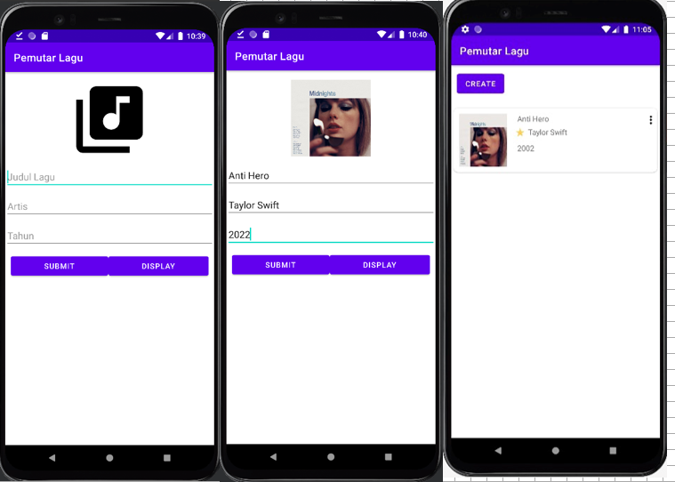

#### Hasil Running Program

1. **Link repository github**

<https://github.com/Alfina041/Tugas7_2018041.git>